SEOUL NATIONAL UNIVERSITY
Office of Admissions, Seoul National University
1 Gwanak-ro, Gwanak-gu, Seoul 151-742, Korea Tel 82-2-880-5021, Fax 82-2-873-5021

Session : March, 2013

Name of Institution : ①
- School/Dept./Major : ② _
- Duration of Enrollment : ③ ∼
- Address : ④ _
- Date of Graduation: ⑤ Degree : ⑥ _

To whom it may concern :

We are pleased to inform that (⑦____________________), your alumni/alumnae or a current student, has been admitted to Seoul National University. Please examine the enrollment record above, complete the verification report below and return it to us as soon as possible. Do not separate the verification report portion as the form is required to be returned in its entirety. Your answers are appreciated and will be held in strict confidence.
Thank you for your cooperation.
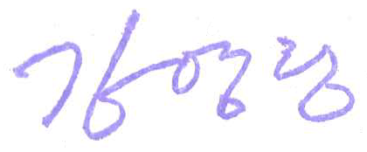
Sincerely yours,

_____________ _
Kim, Young-Hwan
Director, Division of Admissions
Seoul National University

LETTER OF AGREEMENT

To whom it may concern :

Please note that I have applied to Seoul National University in Seoul, Korea for the 2013 Spring Semester and agree that Seoul National University could rightfully make a request for my enrollment records.
In accordance with my agreement, I request your full cooperation to Seoul National University in providing the requested information.

Name : ⑧ (Signature) ⑨
Date of birth : ⑩

VERIFICATION REPORT

Accuracy of above enrollment record : Correct □ Incorrect □
Additional comments :

Name : Title : (Signature)

※ Instructions

1. Please type in English only. Please fill out the form on the computer and print it out to submit.
(Chinese character may be used for Chinese or Japanese schools.)

2. We will send your letter of agreement to the school you have attended in order to ask for your academic information. If there is any falsity on your application or if do not get any response from the school, your admission may be rescinded.

3. Please fill out this form for the last school or university you graduated (will graduate) from.

4. Filling Out Instructions
① Name of School or University you have attended
② Please write down the School(Department) and Major name.
③ Please write down the exact date of admissions(transfer) and date of graduation(withdrawal). Please provide date, month, and year for each date.
④ Full Address of the School or University including Zip Code
⑤ Specific Graduation Date
⑥ Degree Conferred
⑦ Name of Applicant
⑧ Name of Applicant
⑨ Applicant's Signature
⑩ Date of Birth of the Applicant. Please provide date, month, and year.

